Lab Exam

Create a Simple Maven project and create its Build using Jenkins Dashboard

1. Open Eclipse and create a new Maven project.

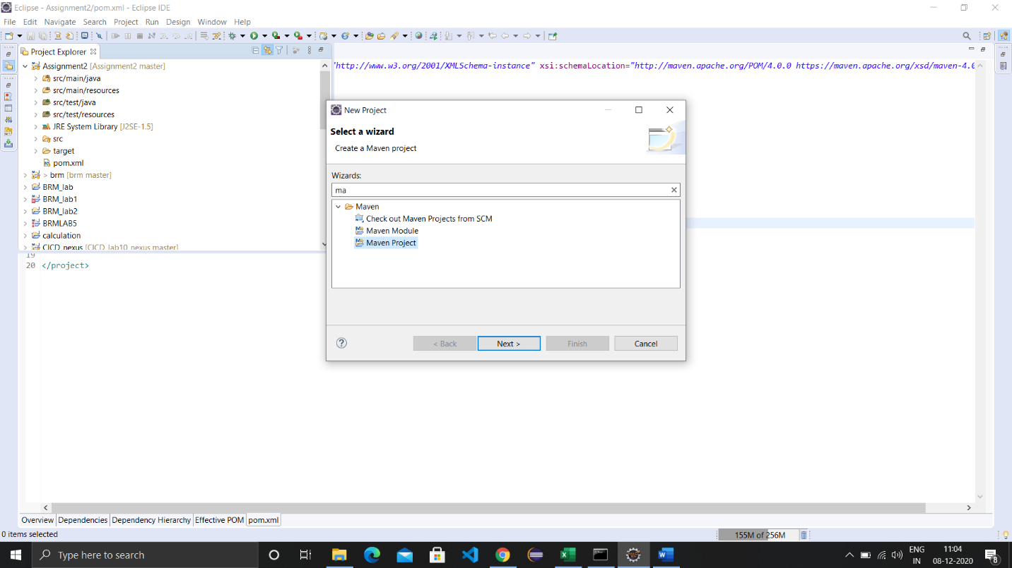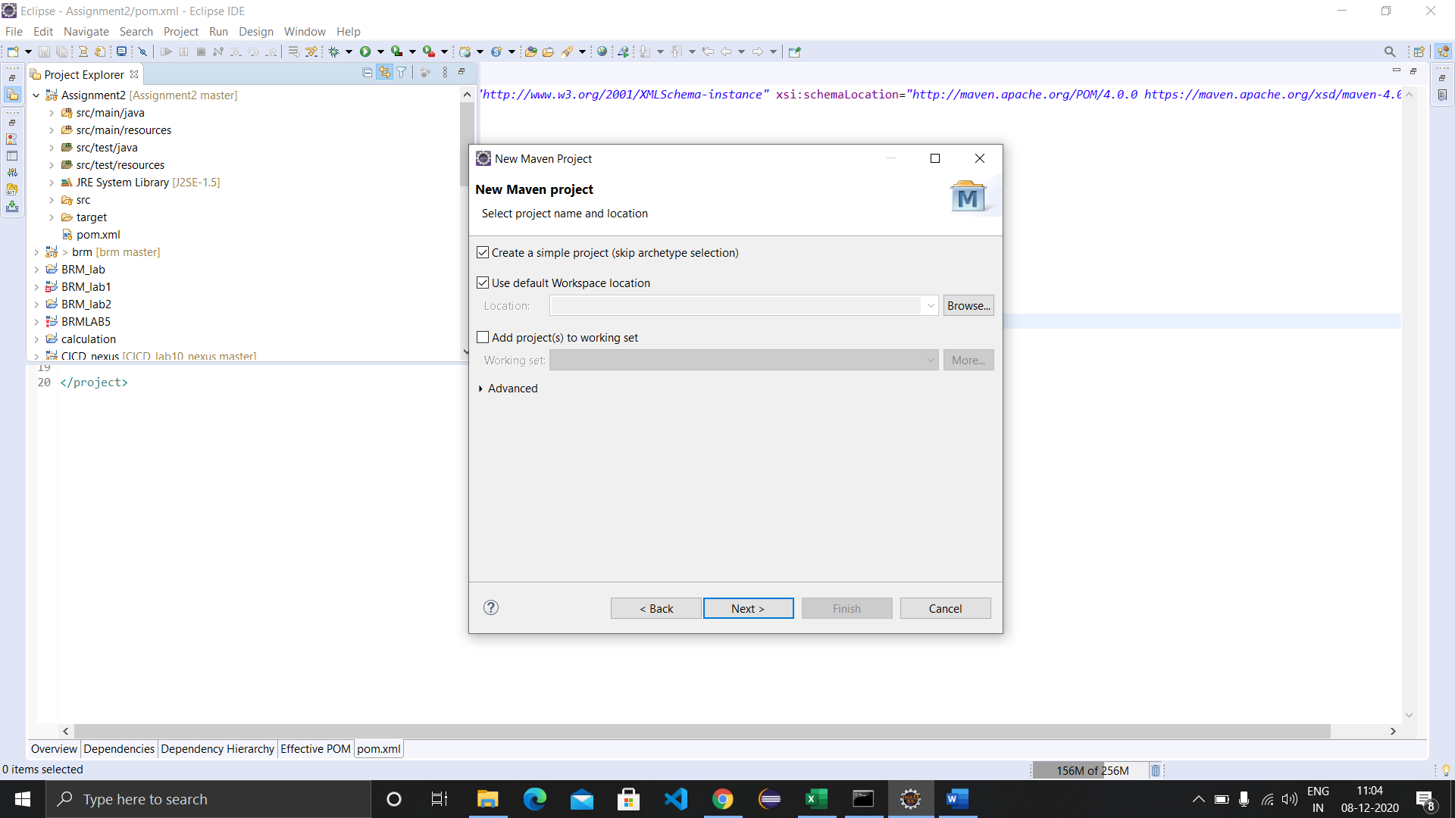

2. Provide a group id and artifact id to the maven project.

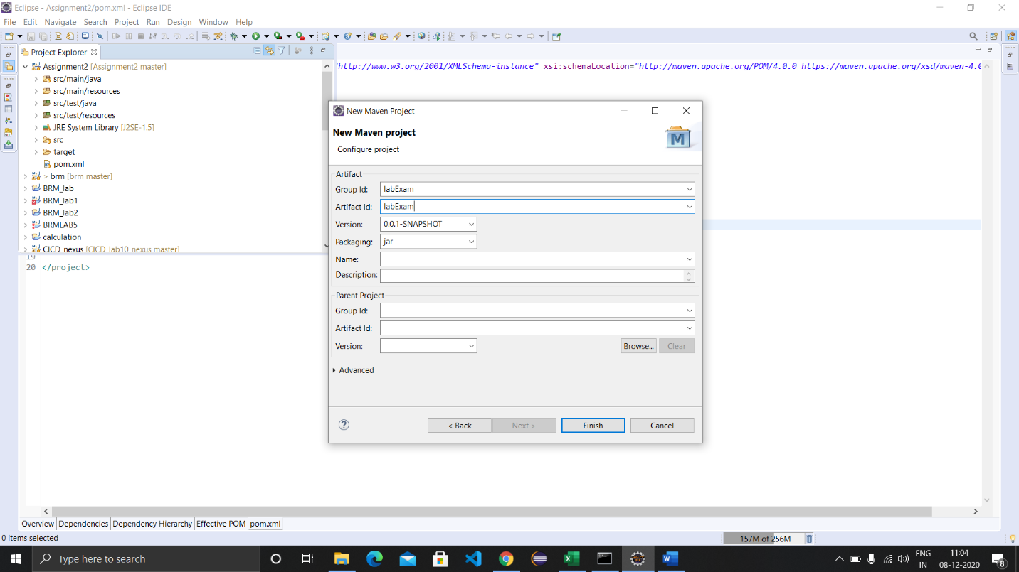

1. Create a new class in the project and enter its name.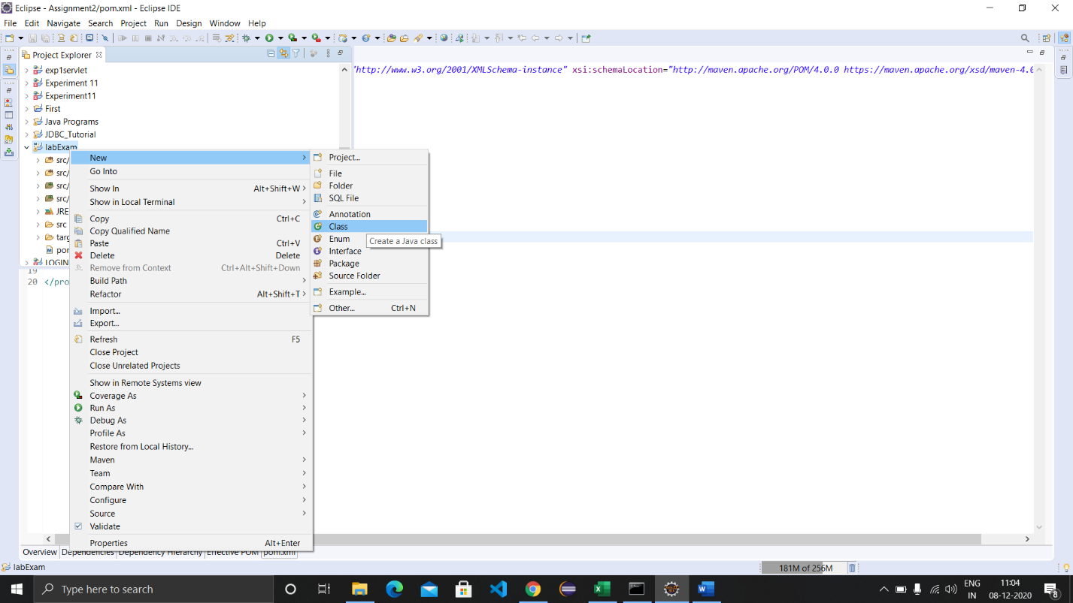
2. Write a simple code in the class.

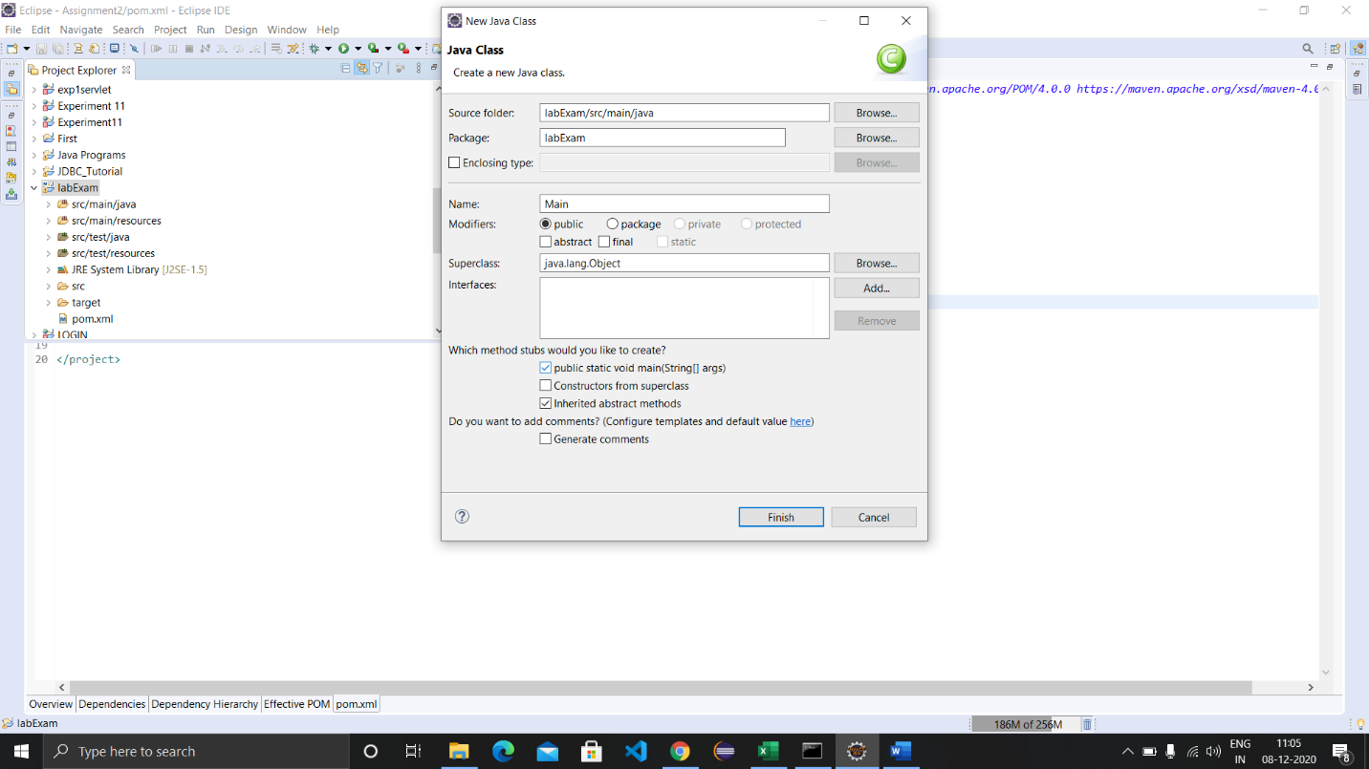

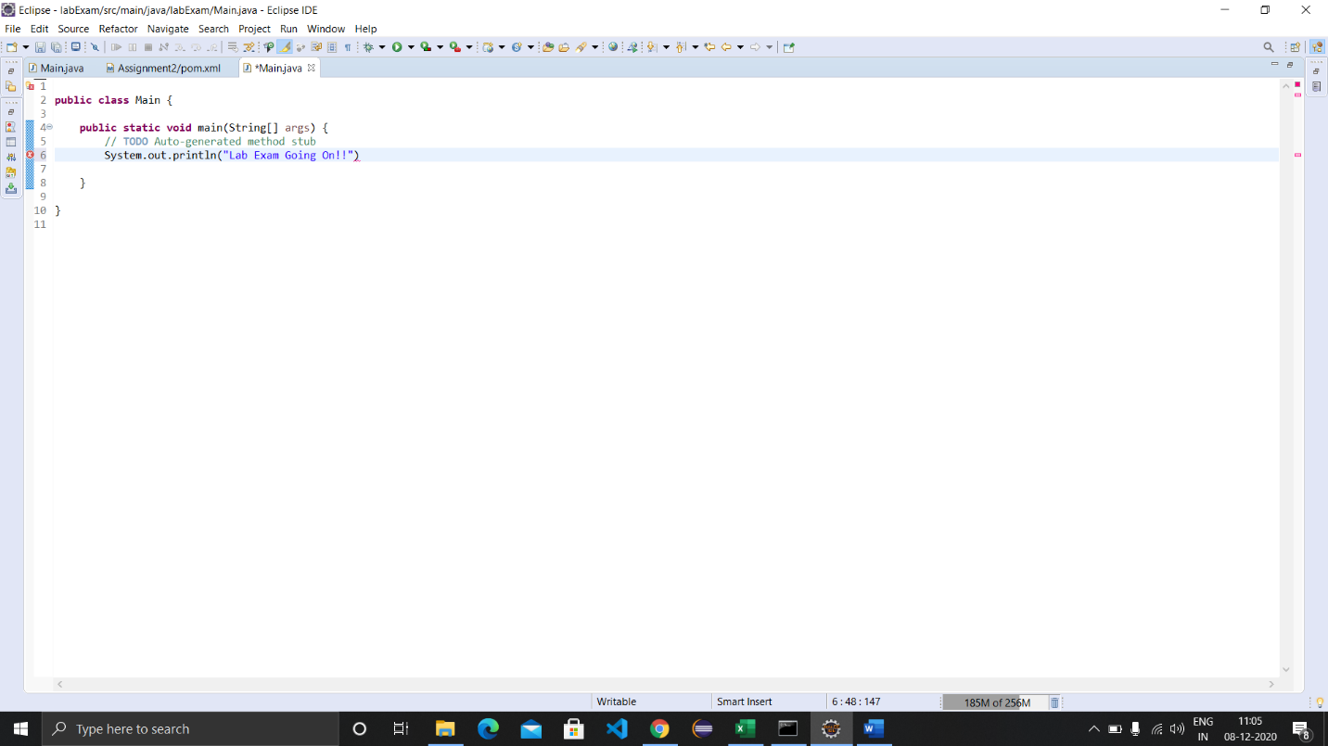

1. Update the pom.xml file by adding build dependency.

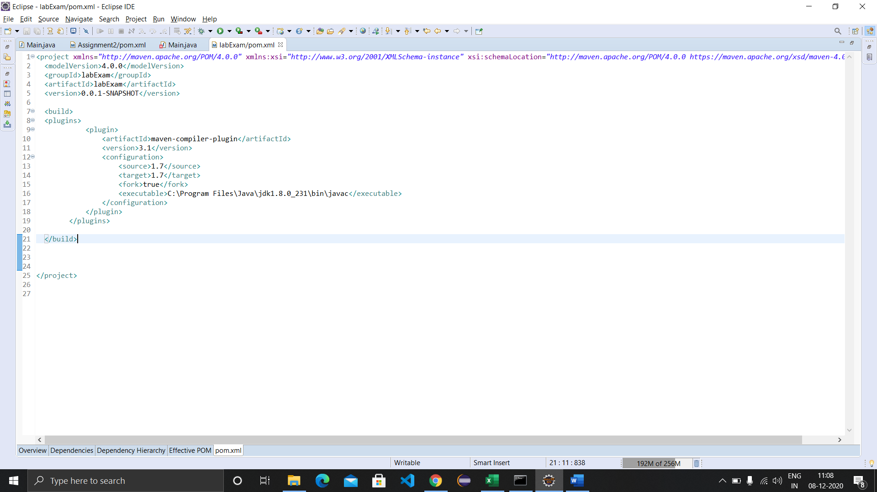

1. Create a new github repository and copy its link.

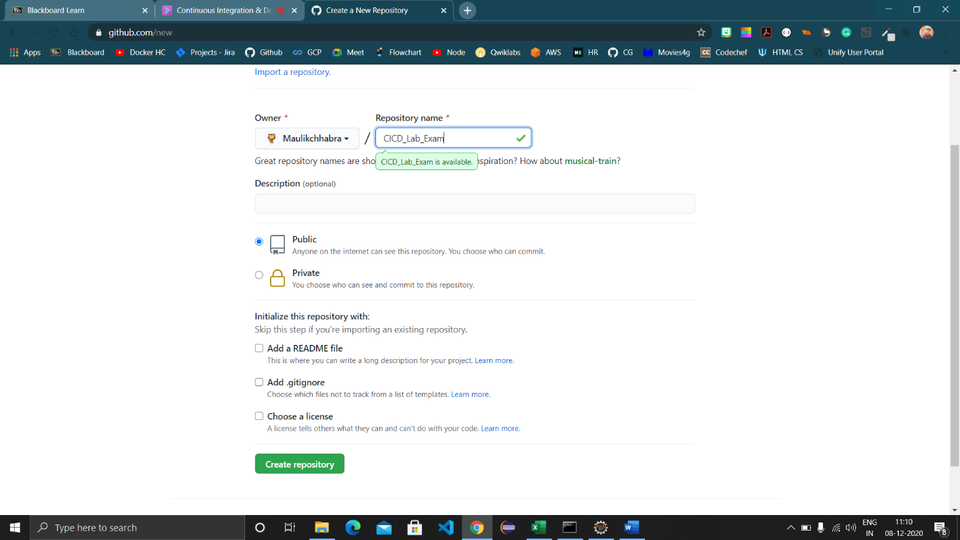

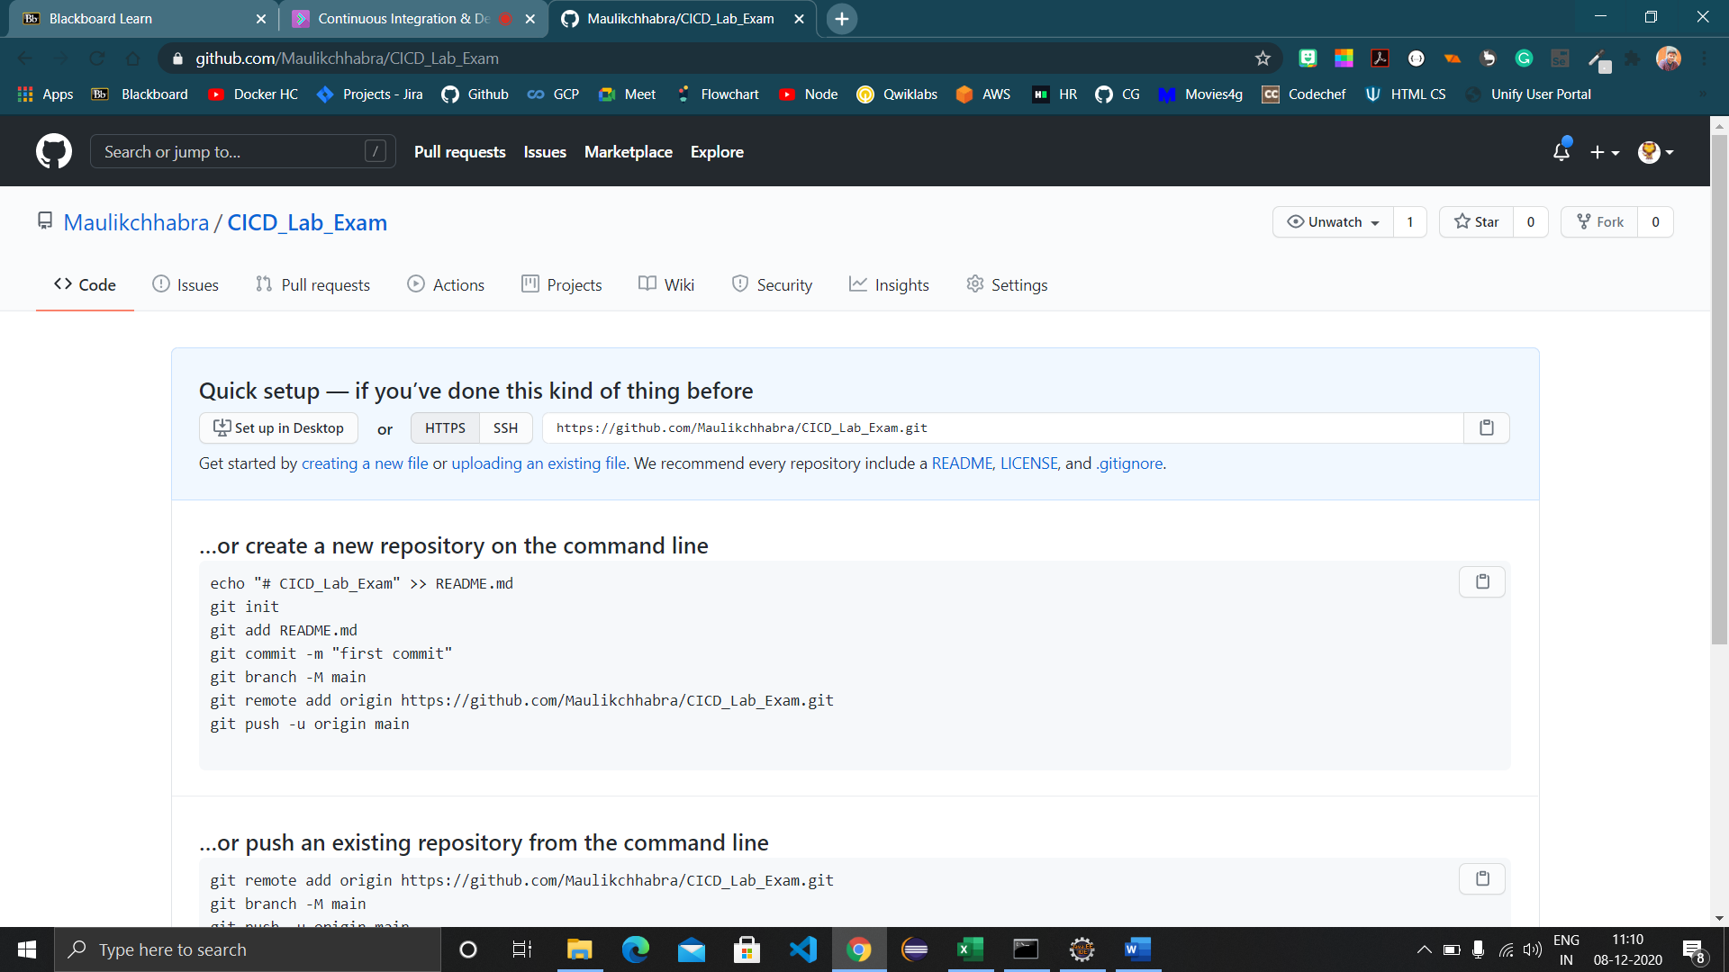

1. Go to repositories section, click on ‘Clone repository’ and provide the copied link here.

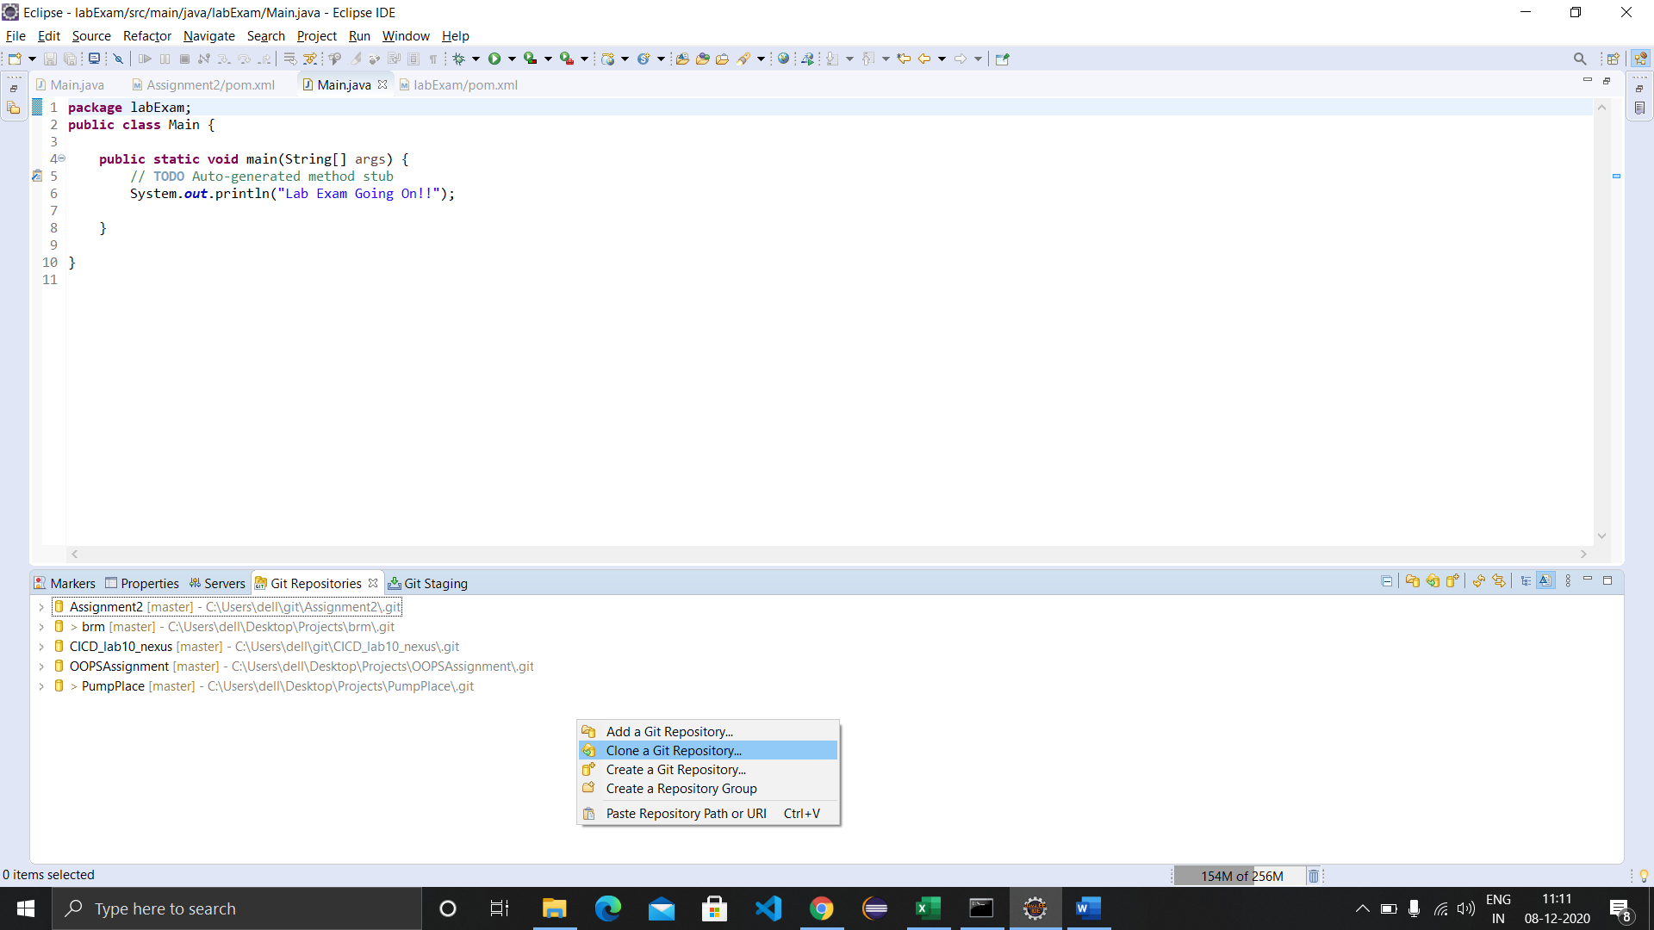

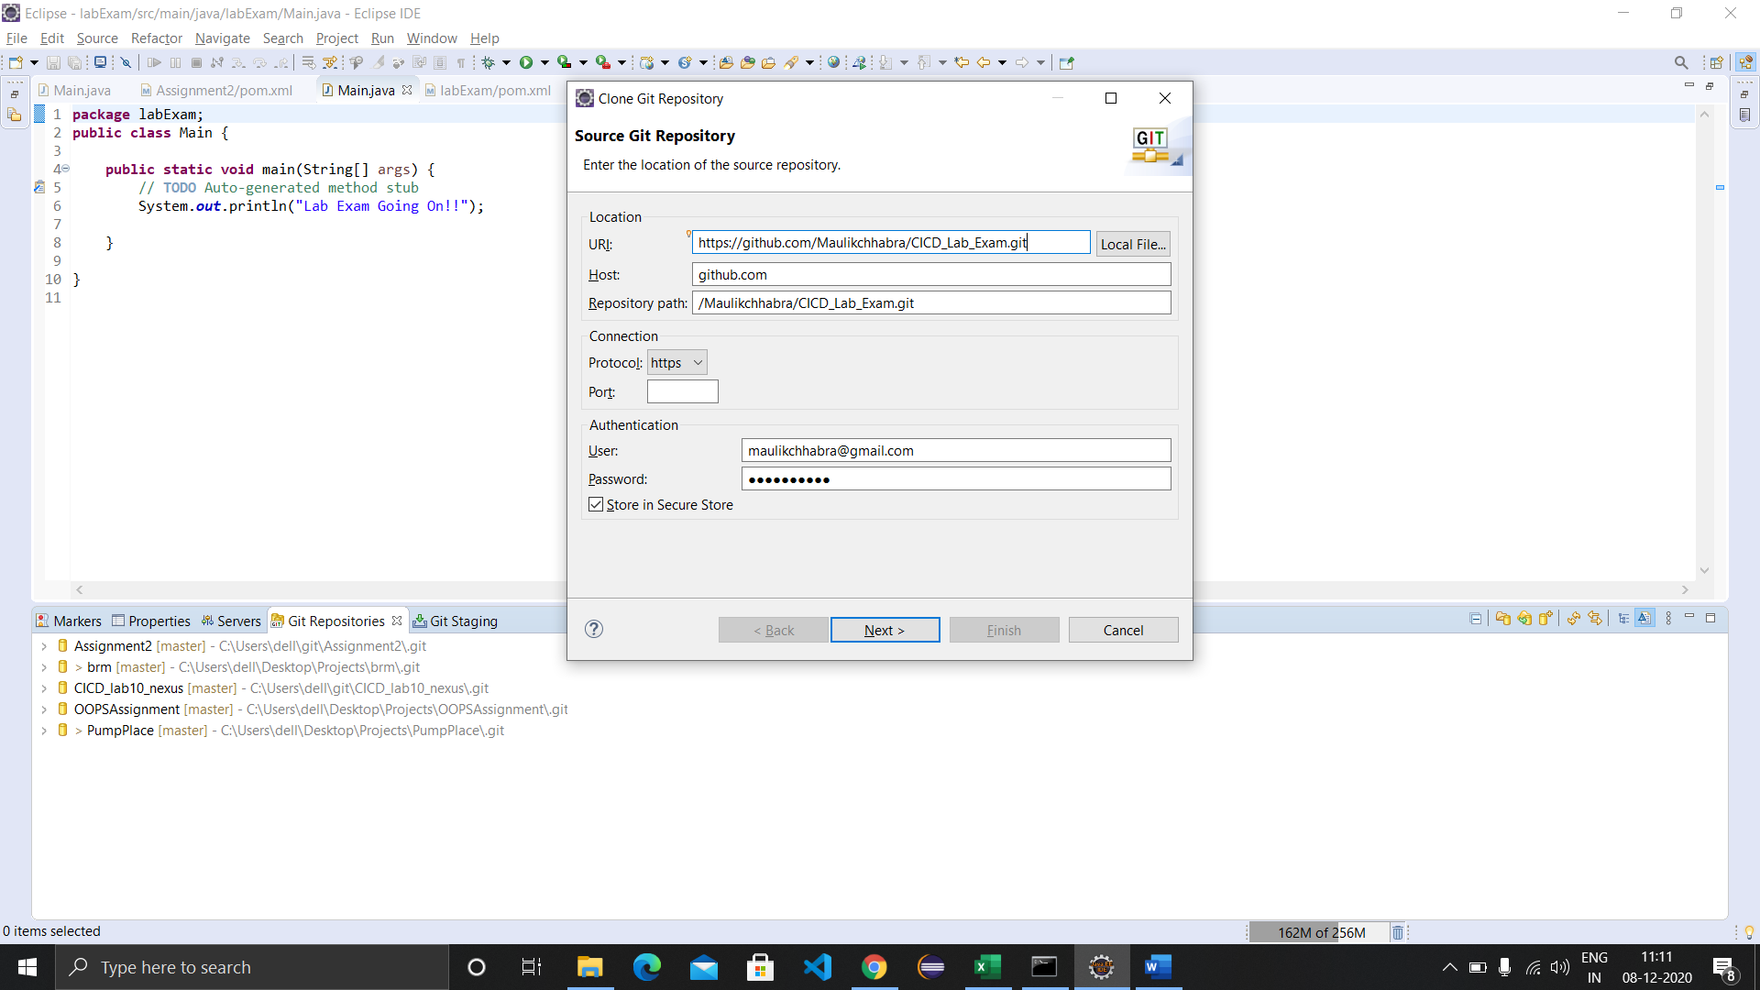

1. Choose the newly made repository in the Team tab.

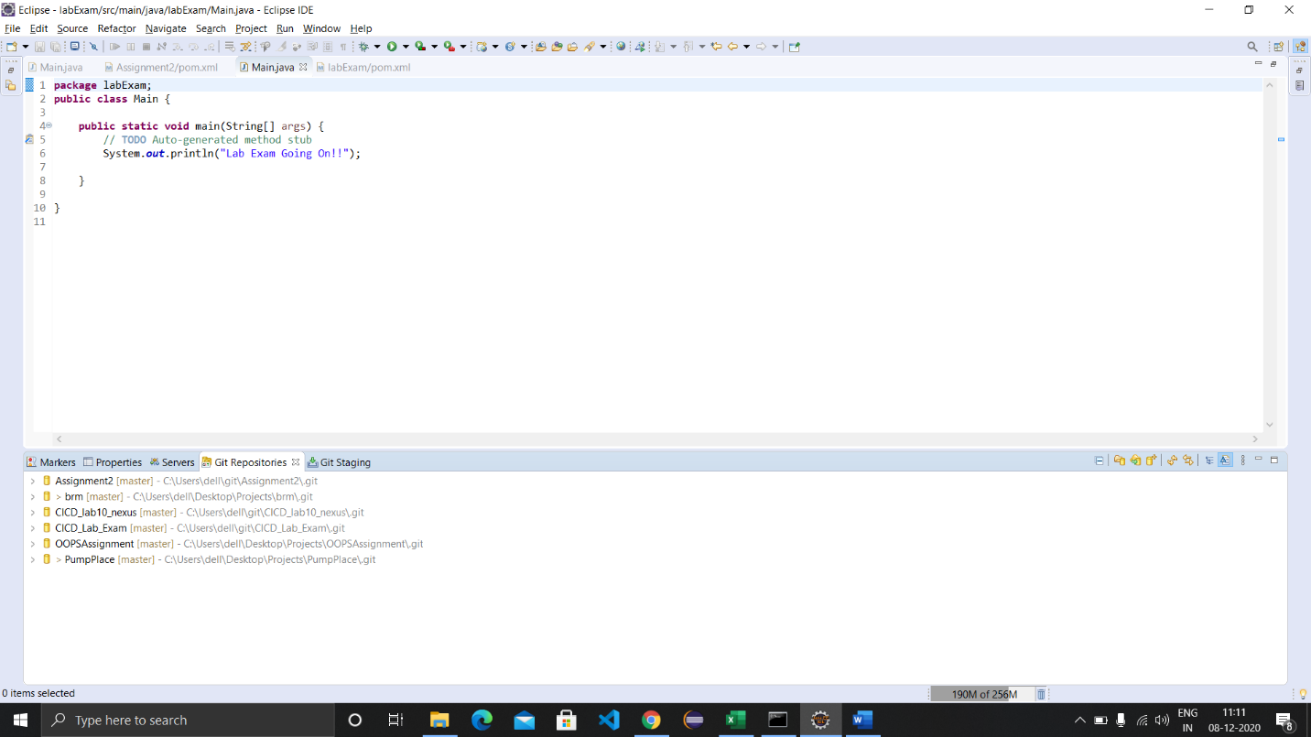

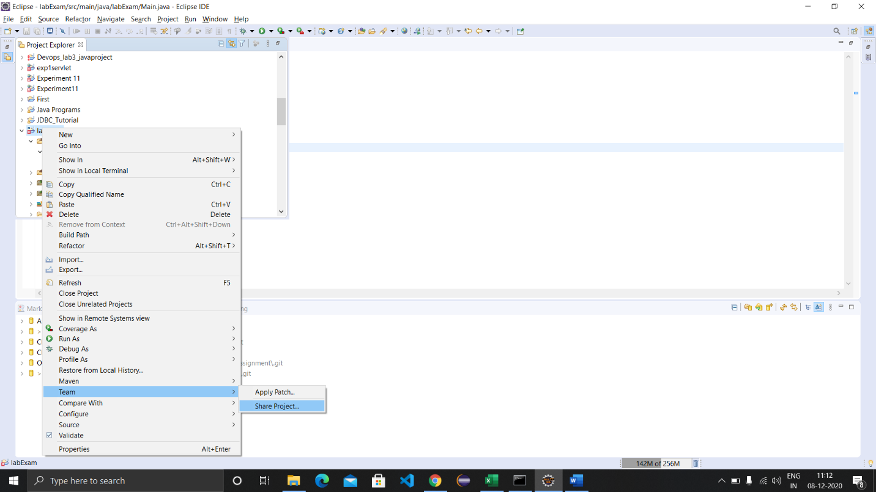

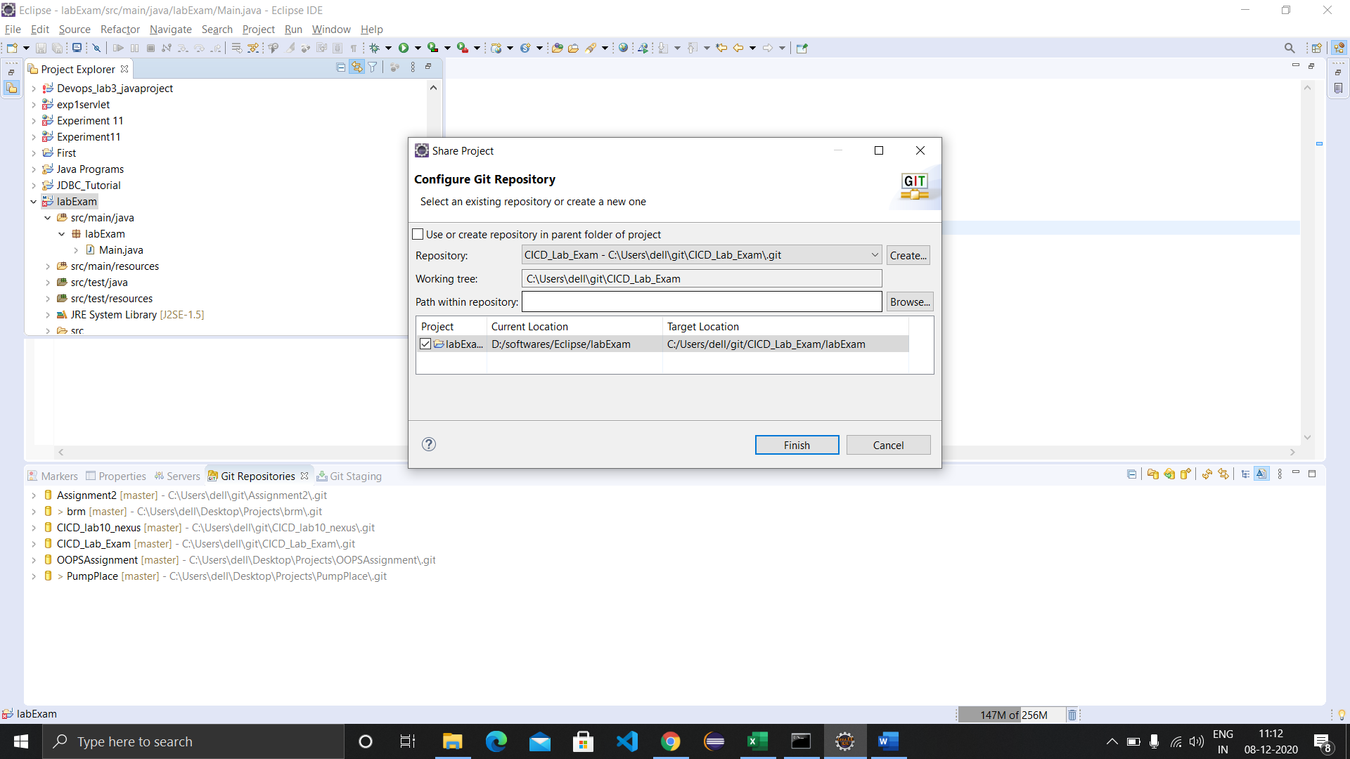

1. Commit and push the source code to github.

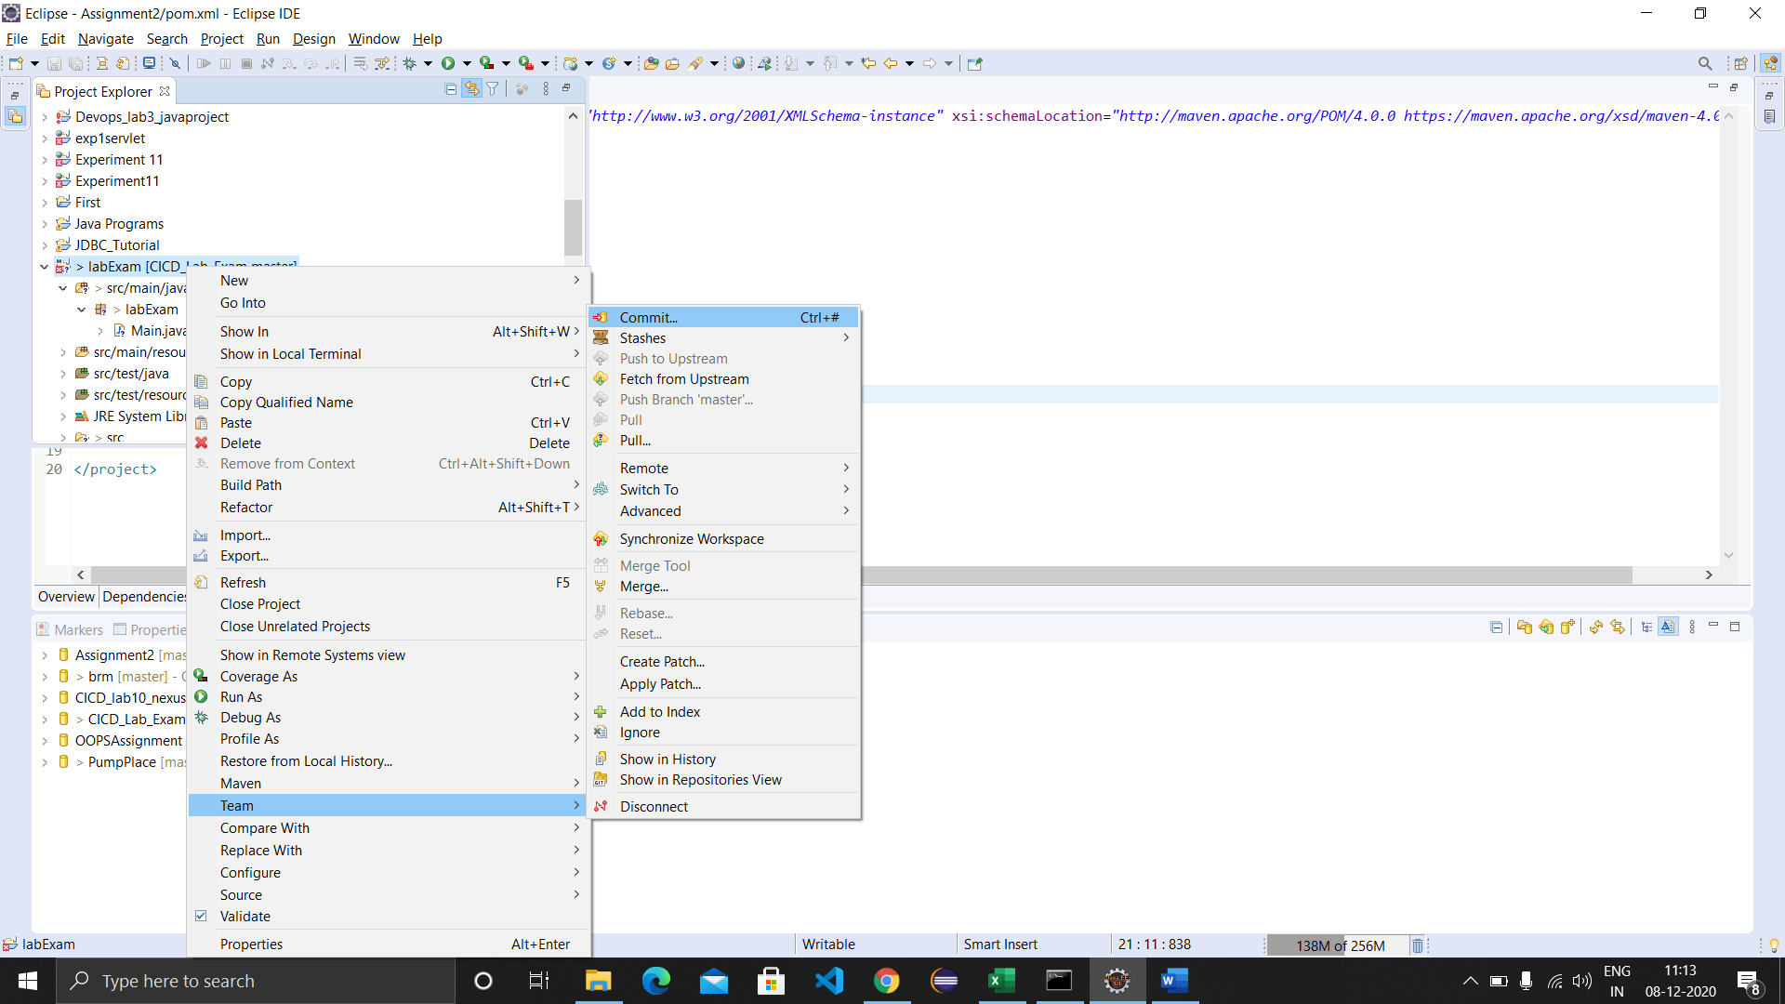

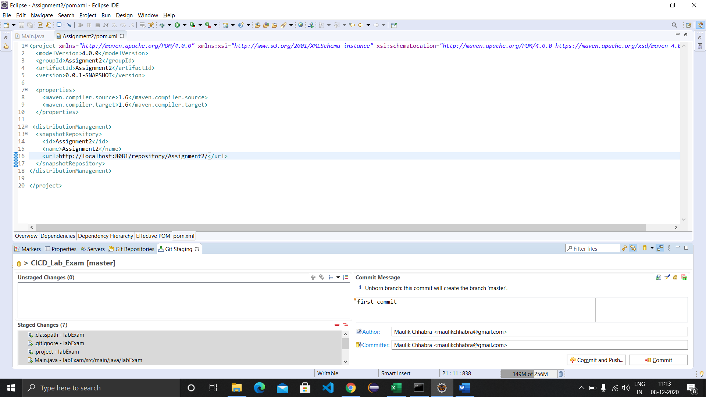

1. The source code is now on github.

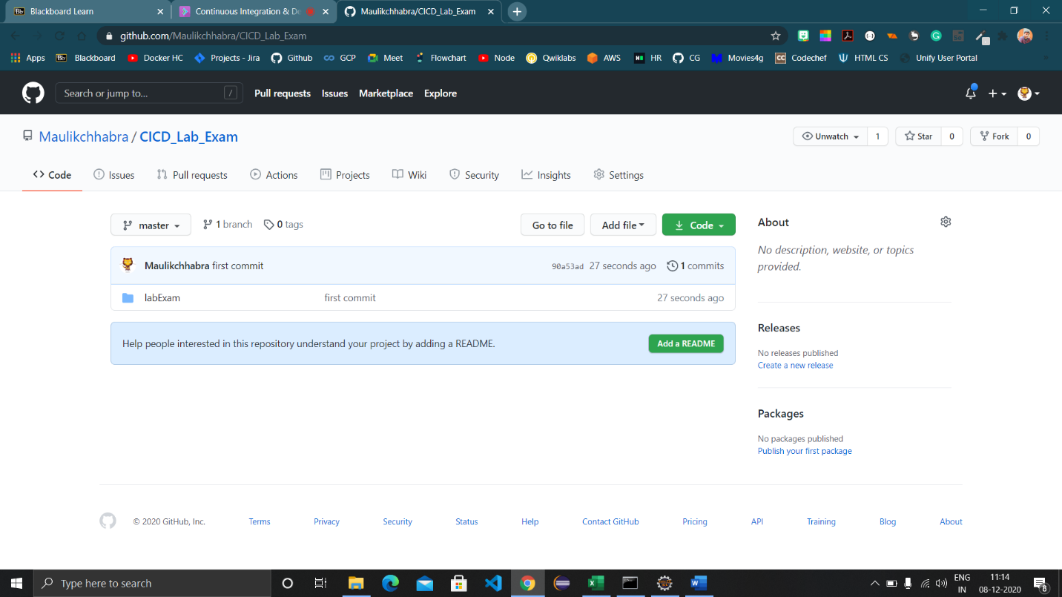

1. Start Jenkins using command prompt using the command ‘java -jar Jenkins.war’.

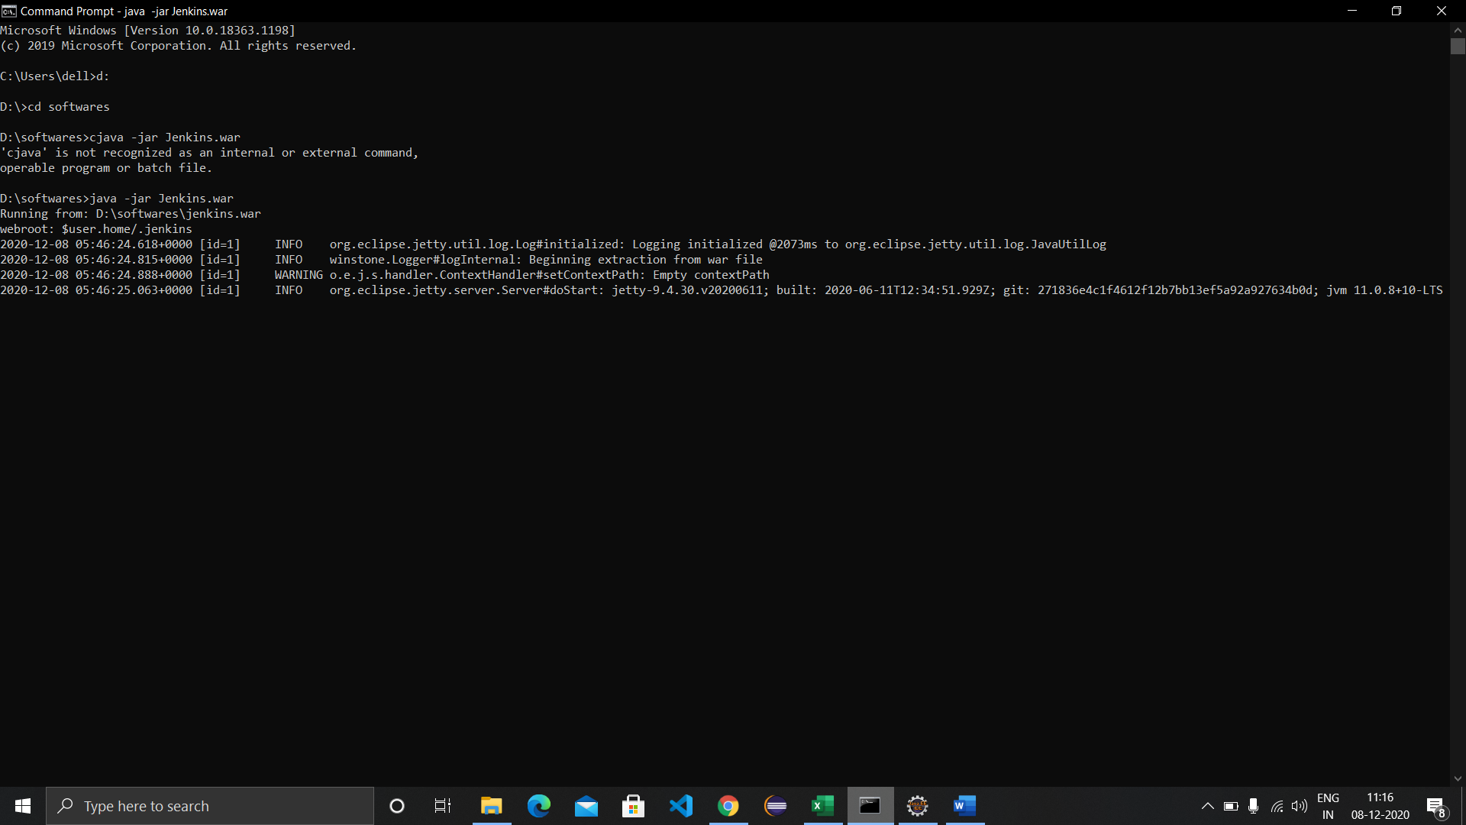

1. Head to the Jenkins dashboard and create a new Maven project by clicking on New Item button.

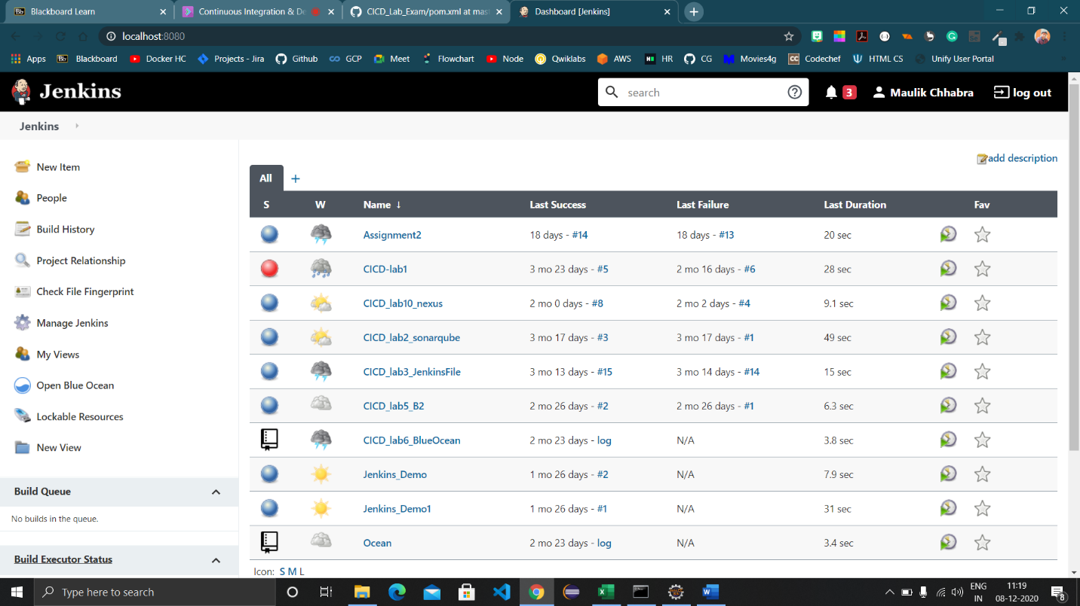

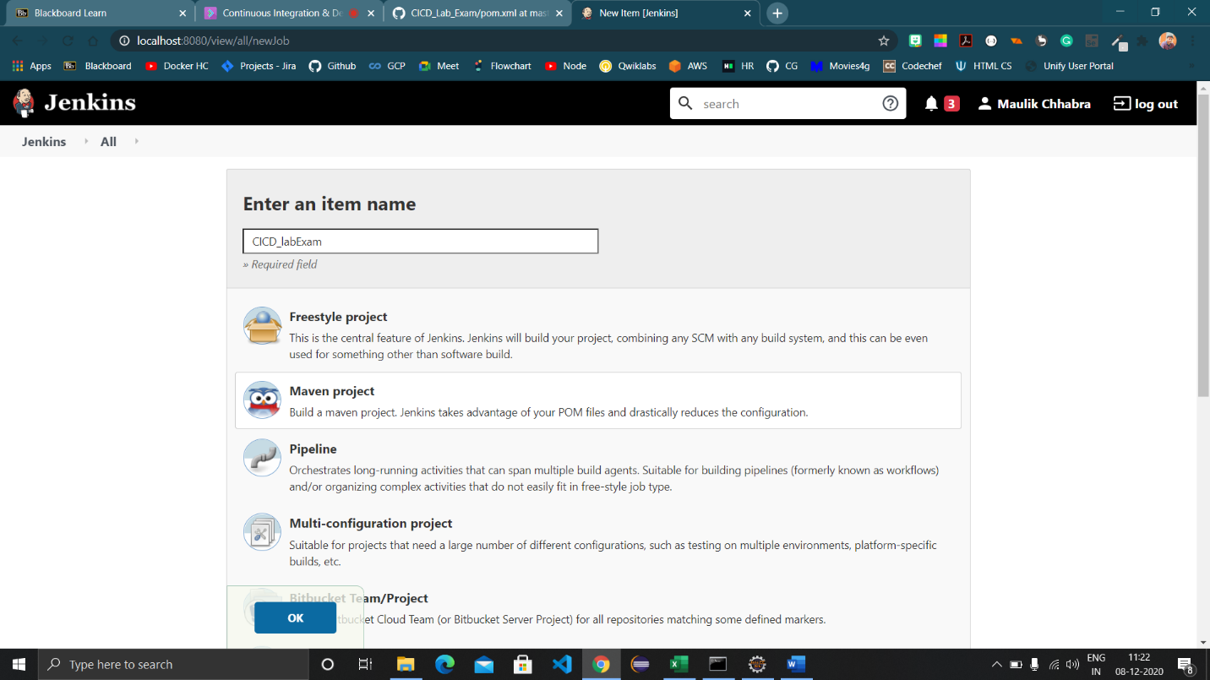

1. Configure the project by providing the github link and path to the pom.xml file.

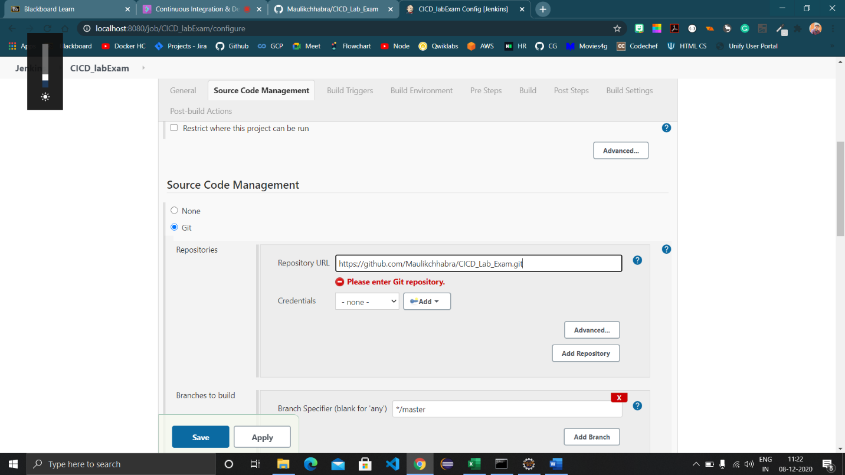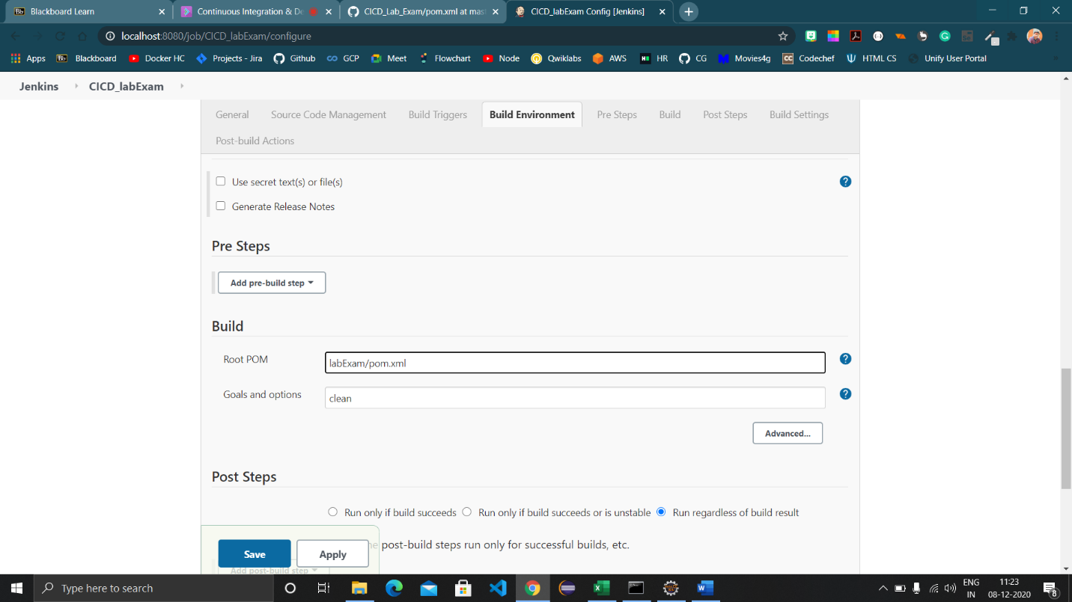

1. Click on Save button and then the project will be visible, click on Build now and choose Console Output.

